The code has two sections.

1. Running the gait file to detect the propulsion phase for both right and left sides.
2. Using the pressure sensor as the gold standard to evaluate the proposed algorithm

To run the code (ProPointPressurePoint_Accel_X_Direction), there are several section mention in the following:

1. In first step after running the code, a window (Figure 1) pops up and ask for the subject’s gait file. After selecting the subject, the height of the subject will be asked in the Matlab window (you can find the height of the subjects in the file called “Control_Demographic_Frailty” in the results section”.

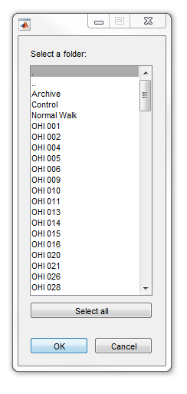

1. Another window pops up and ask about the pressure sensor file. We have to choose the same subject who we chose in the previous section for the gait.

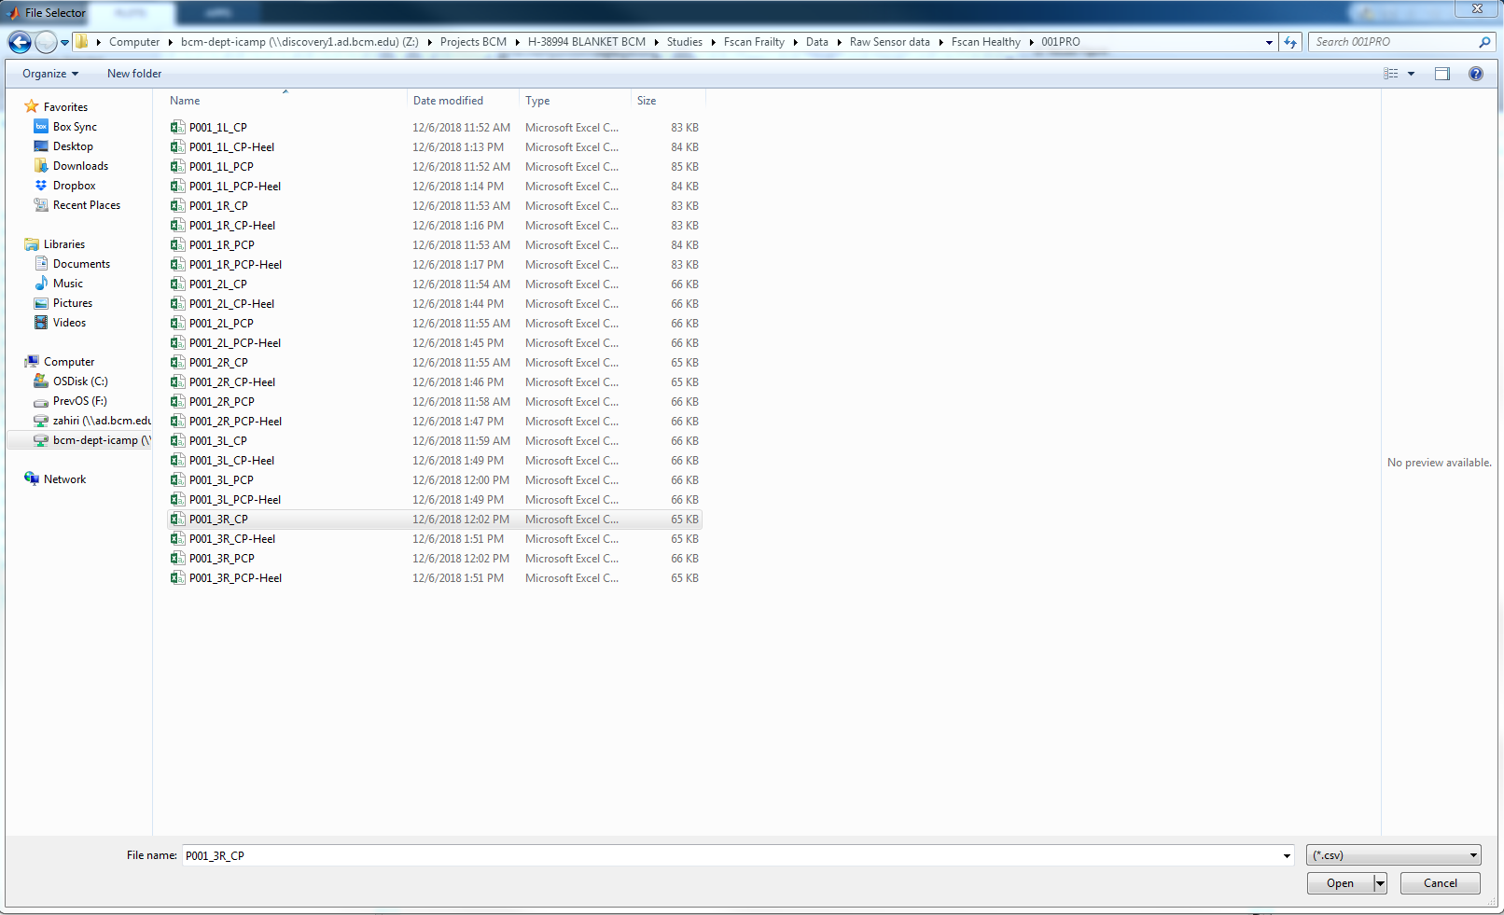

1. To synchronize the gait signal and pressure signal, The 2nd or 3rd point of the heel strike should be selected from the pressure signal in the plot. A new plot including the pressure signal and gait signal appears. In this phase, the user should check and see if both signals are synchronized correctly. If signals are not synchronized correctly, we have to run the code again and choose another Heel strike (for instance, if we chose 2nd heel strike in the first run and the pressure signal has one stride latency compared to the gait, we have to choose the 3rd heel strike in the new run)

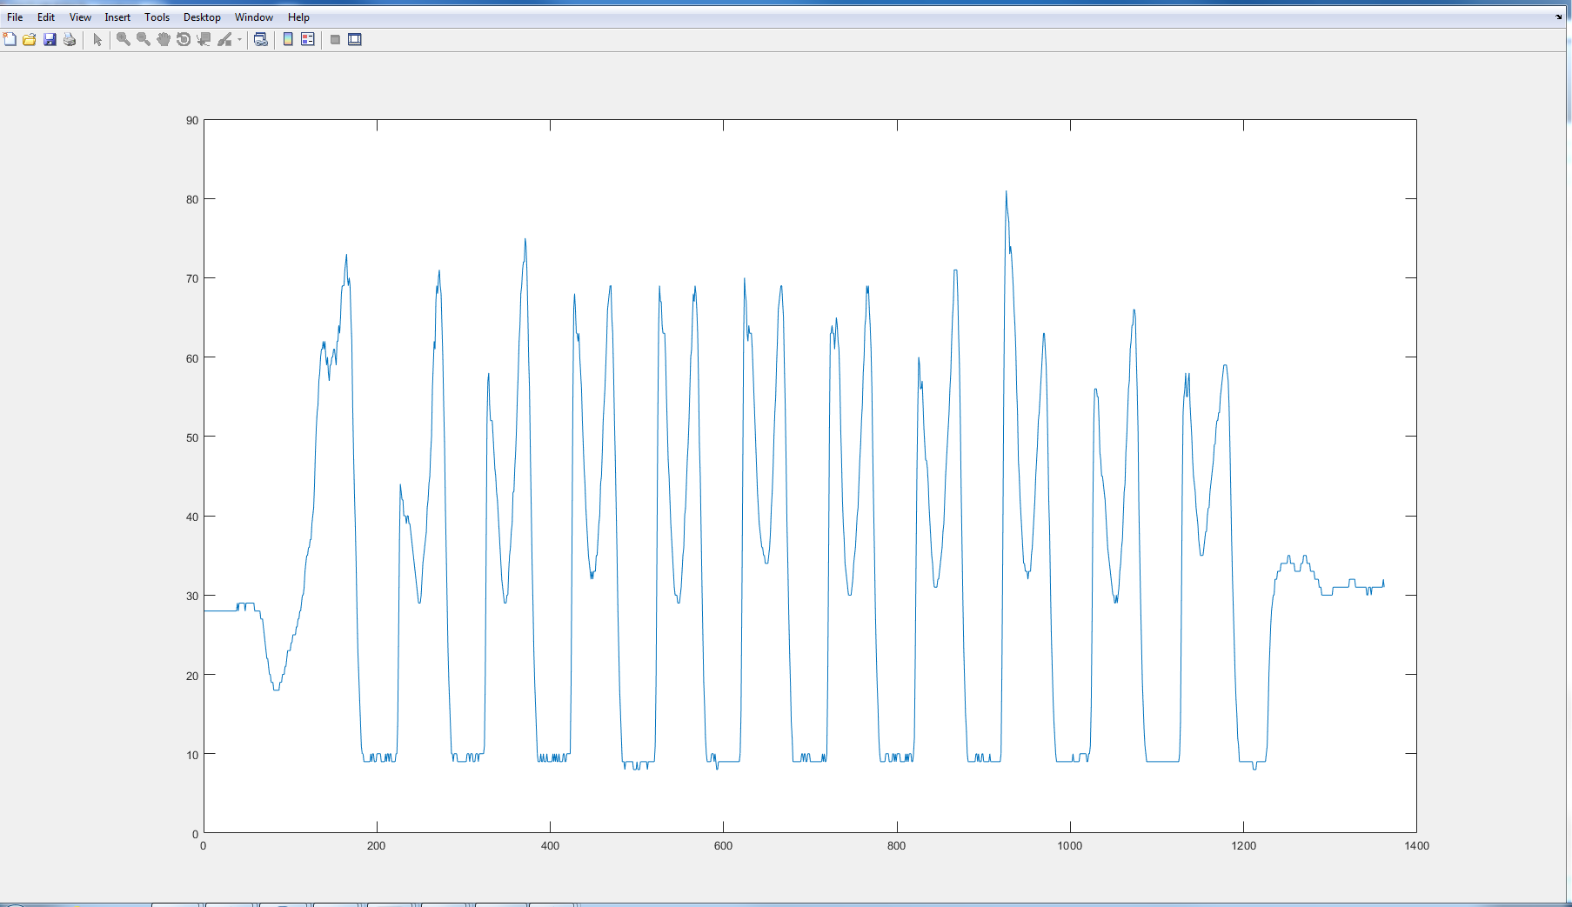

Third Heel Strike

Second Heel Strike

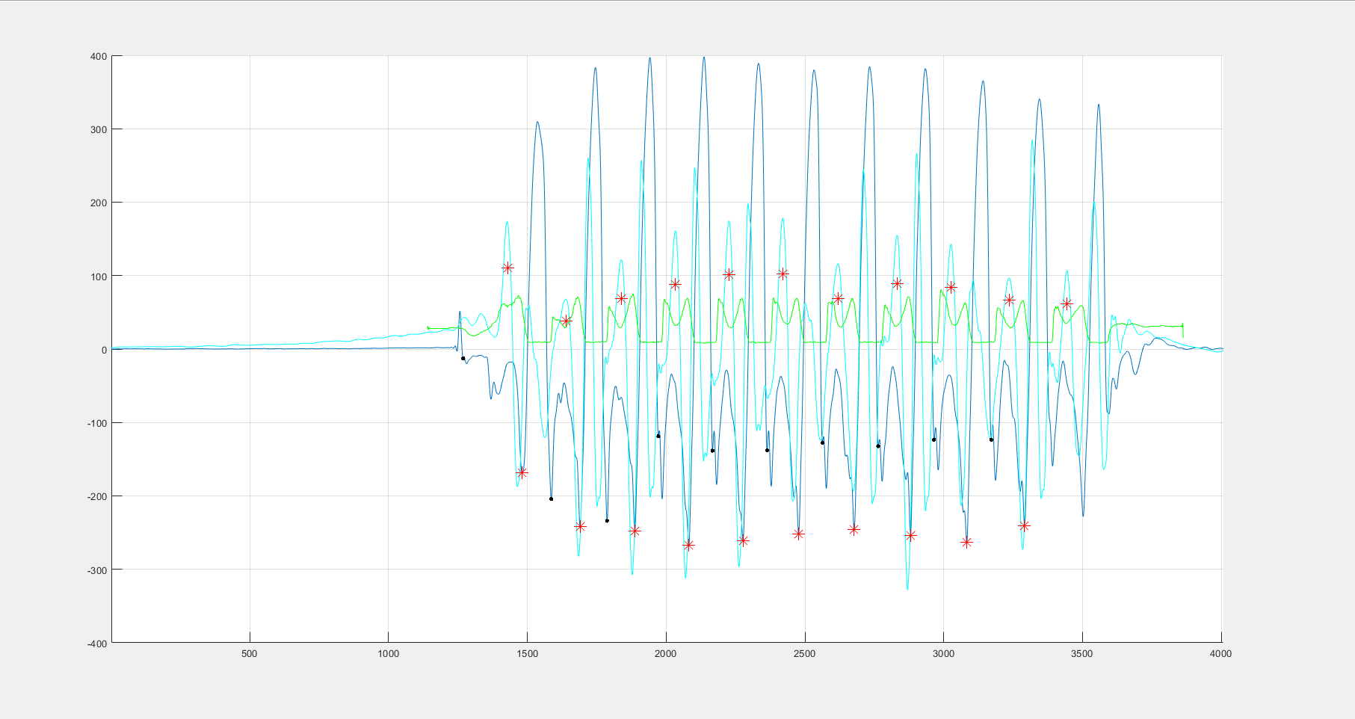

Signals are synchronized correctly

1. If both signals are synchronized correctly, we can select the propulsion points in the pressure signal manually. This point is the local minimum of the pressure signal between two peaks in the stance phase of the walking. After that if there is some strides that we do not have a proper pressure data, we can delete it from the result and save the result again.

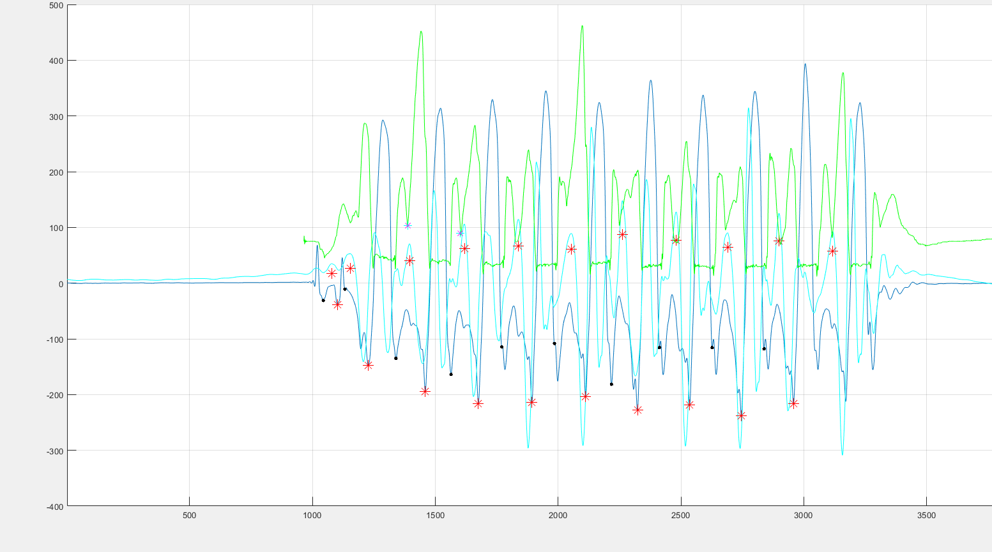

The propulsion phase selected manually